LAB -1

USE CASE DIAGRAMS

1. Online food ordering system

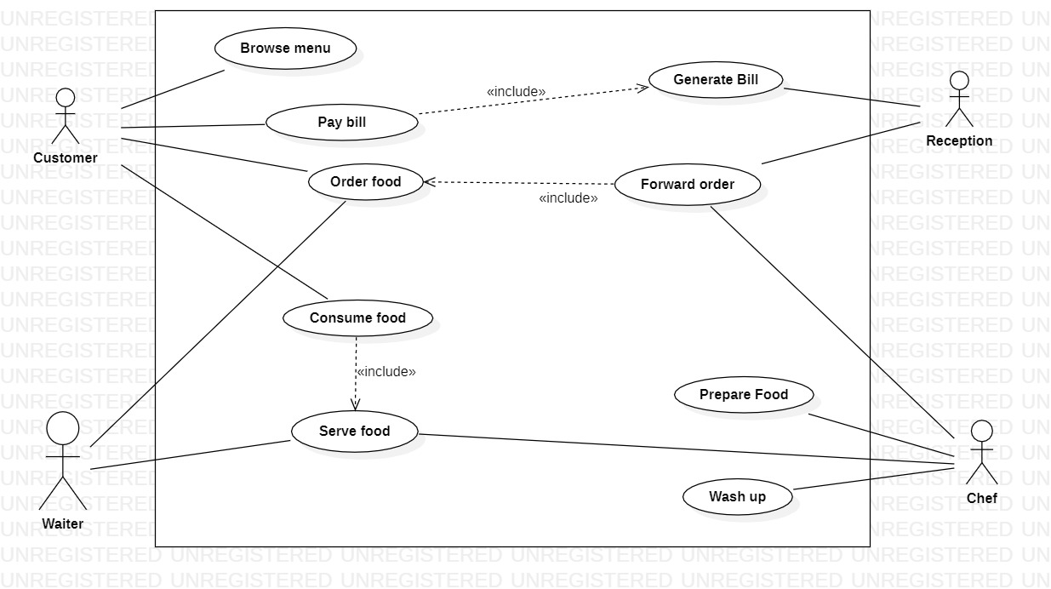

2. Coffee vending system

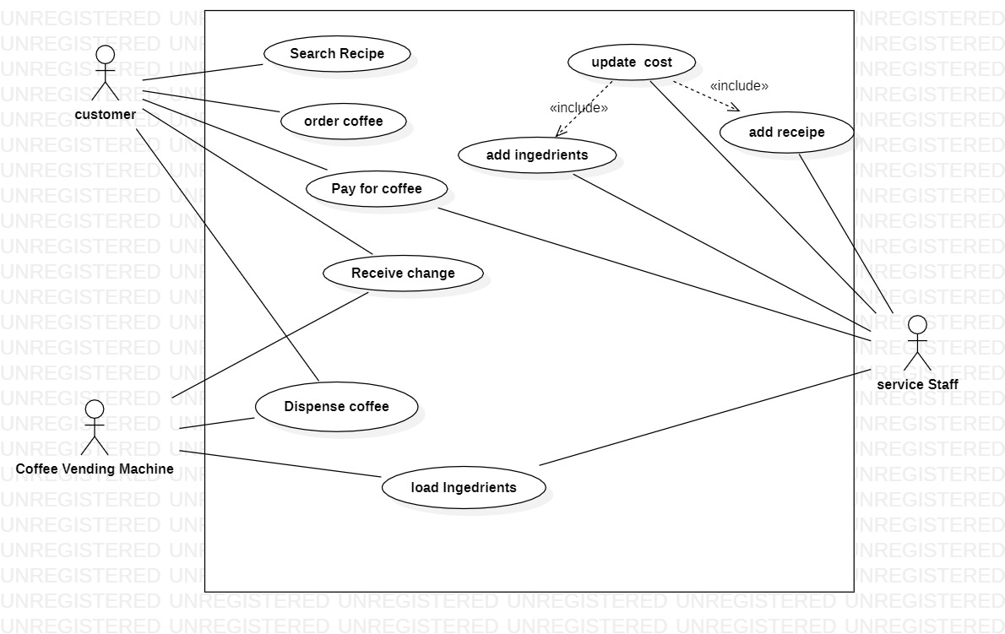

LAB-2

CONCEPTUAL DIAGRAMS

1. University registrar course system

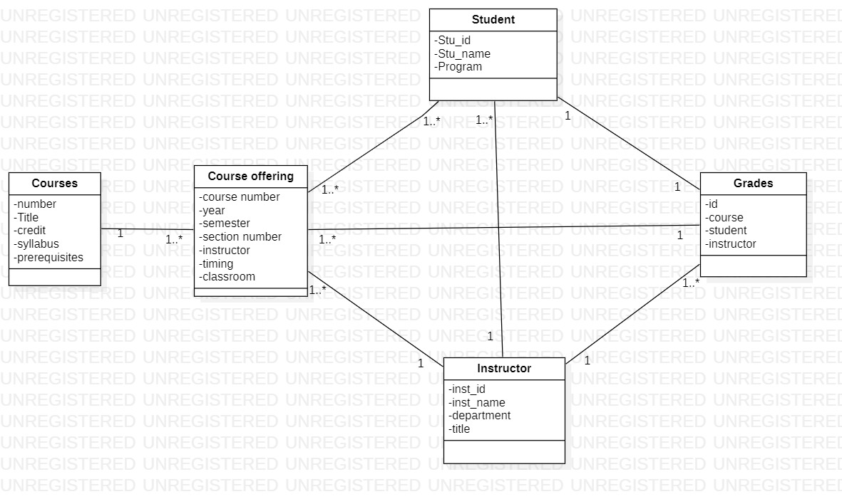

1. Online shopping system

